It’s time to end the cruelty.
Ban live pigeon shoots for good.

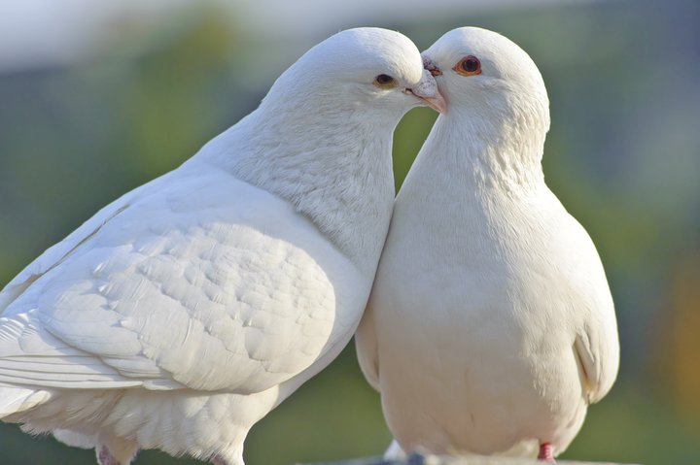

Please vote
‘YES’
on
SB 626

The enclosed editorials are provided by:

Humane USA PA PAC



www.humaneusapapac.org

