

Outlaw all pigeon shoots in Pennsylvania

Published: Saturday, April 30, 2011, 9:46 AM
By Patriot-News Op-Ed
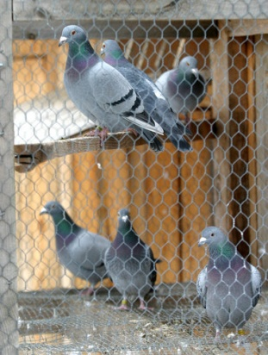
BY WAYNE PACELLE
For decades, compassionate and thoughtful residents have pressed Pennsylvania lawmakers to outlaw live pigeon shoots. These displays of wanton, stomach-churning cruelty have no reasonable justification — and each year the national spotlight of shame shines brighter on the state Capitol in Harrisburg. Pa. is the only state that currently allows shooting of live pigeons for target practice.
Perhaps these events, in which live animals are used as living targets in so-called sporting matches, occur elsewhere in the shadows of American life. But there is no question that Pennsylvania reigns supreme as the place where this senseless slaughter occurs openly, year after year.
Organizers of these events trap thousands of live pigeons, mostly from cities, it is presumed, and truck them to the slaughter fields. The birds are stuffed into spring-loaded boxes and then launched into the air just yards in front of waiting shooters. Prizes are awarded for kills. Nobody eats the birds, and these creatures, with bodies full of lead shot, are just thrown in the trash. As you might guess, many birds are not killed outright, but wounded. Some are left to suffer for days and weeks. Neighbors report finding maimed and dying birds on their property.
More than 20 years ago, I witnessed what was then the country’s largest pigeon shoot, in Hegins, Pa. It was a macabre spectacle, unfit for eyes — unreal and yet so horribly real. I’ll never shake the revulsion I felt at seeing children, young boys, sent onto the fields to stomp wounded birds to death or to twist off the heads of the maimed. What kind of values were adults teaching? It seemed to me like a cruelty training camp, and it left me wondering whether these kids would have all of their natural empathy for animals entirely drummed out of them.
Though the Hegins shoot was eventually shut down, other events continue here and there today at private gun clubs. A new bill in the state Senate, S.B. 626, would prohibit this practice for good. Already the legislation has bipartisan support from 18 co-authors, and it has been overwhelmingly approved by the Senate Judiciary Committee.
Wayne Pacelle
The lobbying chieftains of the National Rifle Association can be counted on this year as in years past to use their political capital to fight this bill. This spectacle has nothing to do with hunting or gun rights. The reality is, many rank-and-file NRA members oppose the shoots and for all the right reasons.
One NRA member who knows his stuff is W. Scott Yoder. As a boy, he was among those “trapper boys” called upon to rush into the fields to kill wounded birds that survived the first round of shooting. He writes that even as a child, he knew that these events were wrong. He saw wounded birds that escaped and continued to suffer, and was left to wonder why. Today, Yoder campaigns to stop live pigeon shoots.
There’s no redeeming value in maiming and killing animals in the name of fun, prizes or mere target shooting. There are plenty of ways to test your shotgun skills short of using live creatures. There are plenty of ways to engage children in valuable life lessons without exposing them to crass heartlessness.
The spectacle of pigeon shoots has nothing to do with hunting. It brings forth not a single redeemable social or individual value. It leaves untold suffering in its wake. It belongs as a shameful footnote in Pennsylvania’s history books.
WAYNE PACELLE is president and CEO of The Humane Society of the U.S. and author of “The Bond: Our Kinship with Animals; Our Call to Defend Them.”
© 2011 PennLive.com. All rights reserved.

